Mahitahi Hauora Education Update – June 2023

Professional development
For more professional development opportunities, please visit Home page - Mahitahi Hauora Primary Health Entity

Either scroll down on front page and you will find a box on left hand side CONTINUING MEDICAL EDUCATION / CONTINUING NURSING EDUCATION
Or go to HEALTH & WELLBEING PARTNERS Professional Development in second column
Or https://education.mahitahihauora.co.nz/w/upcoming/
Look out for weekly Professional Development Medinz – Thursday morning at 10am highlighting upcoming Professional Development opportunities in Northland.
Back issues of this Education update are available on the Mahitahi website

Mahitahi Hauora Education sessions
More information available via our education website - Home page - Mahitahi Hauora Primary Health Entity

IV Cannulation – Registration of interest in IV Cannulation training

If you require IV Cannulation training, can you please put your details on the registration form before 8th of July 2023. We will then assess the need and arrange training asap.
The link to the registration of interest form is: https://education.mahitahihauora.co.nz/register?sgid=b564cf11f7914298899e381f1964118a

TONIGHT
Optimising Hypertension Management in Primary Health Care – Mahitahi Study session - online
20th June 2023 6.00 to 7.00pm
Find out about latest evidence regarding managing hypertension, Overview of Whangarei Hospital’s hypertension service and ongoing education opportunities & support. Presenters Dr Sharen Supershad – Renal Physician and dedicated specialist in clinical hypertension with the American Society of Hypertension, & Kate Burson – Hypertension Clinical Nurse Specialist from Te Whatu Ora Te Tai Tokerau
All Te Tai Tokerau health professionals can register for this FREE course please use this link:
https://education.mahitahihauora.co.nz/w/ or https://education.mahitahihauora.co.nz/register?sgid=e26785bd18b04566ba04f45248776afc

Code of Rights, Privacy, Confidentiality & Choice – Mahitahi Study session - online
22nd June 2023 – 12.30pm to 1.30pm – Lunch time session
With Jessica Buddendijk from Mobile Health/ Rural Health Development
To register for this FREE course please use this link:
https://mobilehealth.zoom.us/webinar/register/WN_58r9aHMwRSGHDg5Q_fdcRw#

This course is being run again on 12th of September from 6.30 to 7.30pm to register for the evening session
https://mobilehealth.zoom.us/webinar/register/WN_CXRb4qZbSz--3_EVWwivFg

Health Related Education sessions
Dated and timed sessions that we have heard about

Goodfellow Unit Continuing Professional Development
- Webinars:
  - June 27: Immunisations in the clinical context Register here
  - July 4: Travel medicine (with a focus on high-altitude travel Register here
  - July 11: Responding to crisis presentations Register here
  - July 25: Early diagnosis and post-operative care of head and neck cancer
Register here
- Workshop:
  - June 29/30: Sexuality and Intimacy Information here
- About alcohol:
  - Podcast – Alcohol use in New Zealand Episode here
  - Short course – Older adults and drinking Course and resources here
  - Webinar archive – Talking about alcohol Talk and resources here

Certificate of Advanced Dermatoscopy
29-30 July 2023 – 2 day interactive course designed for GP’s.
City Campus, University of Auckland. Course fees apply. More info can be found via the Medinz link here : https://medinz.co.nz/msg/2023-05-25-certificate-of-advanced-dermatoscopy

New Webinars from My Health Hub
New Recorded Webinar:
ASTHMA – Strategies to Optimise Patient Self-management https://myhealthhub.co.nz/5662-2/
Upcoming Live Webinar this month:
- Youth Mental Health – Supporting our young people – Wednesday 28th June 7pm to 8pm

Register at https://myhealthhub.co.nz/webinars/

We are working on many other courses:
- Kidney Wellness
- Wound care
- Child Protection referrals in Northland
- How to get the most out of your HIP & Health Coach
and we will publish more dates and times when we get confirmation from speakers and venues.

CPR next courses will be in late October early November.

Keep an eye on our education site to register and find out more information. https://education.mahitahihauora.co.nz/w/upcoming/

Hopefully your team are all enrolled in Medinz, as we advertise clinically relevant courses by email each week at 10am Thursday.

Training idea for the month

Check out Child Protection training on Safeguarding children website https://lms.safeguardingchildren.org.nz/catalog
Fundamentals of Safeguarding and Child Protection
Here is one of their webinars that one of our mental health team completed last week. She said it was very informative and went through the legislative requirements but was also very practical as far as note taking advice and making reports of concern. This course also teaches about family violence.
There is a minimal cost, and the course takes 3 hours but can be accessed for 30 days.
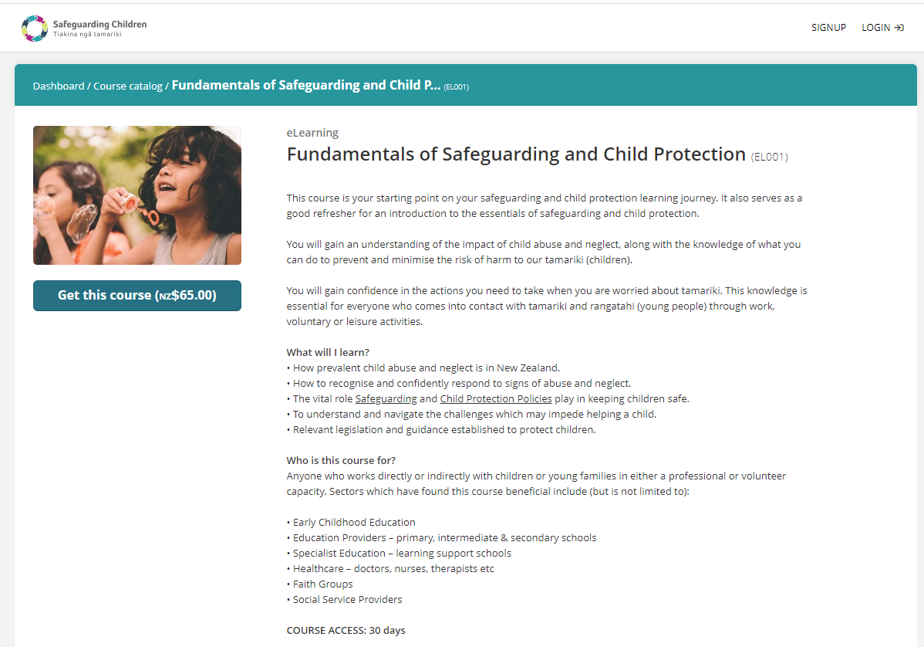

Queries or ideas
Any queries or comments on this Education update or any training or education ideas you may have; please contact Education@Mahitahihauora.co.nz or Phone Rae Jones on 021 869 712

