Your GP has requested a breathing test (spirometry) to diagnose or monitor any respiratory symptoms you may have.

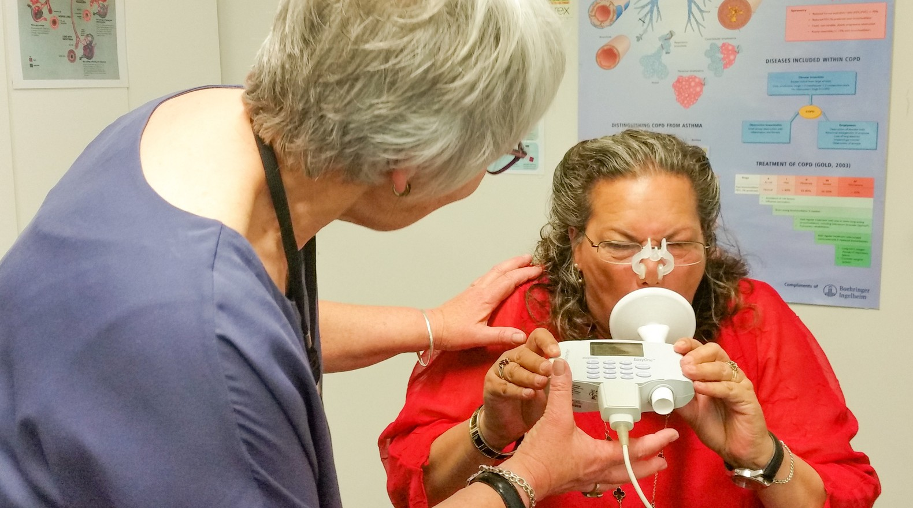

**Spirometry**

# Your appointment

*Please arrive 10-15 minutes early. You will be asked to sign a consent form. StaffCare will keep a copy of your spirometry report. A copy will be emailed to your GP. You can ask for a copy of it, and you can get another copy anytime in the future.*

**Date:**

**Time:**

**Location: StaffCare, 32 Reyburn Street, Whangārei (behind White Cross), phone:** [**09 438 8324**](https://www.google.com/search?q=staffcare%2Bwhangarei%2Bphone%2Bnumber&oq=staffcare%2Bwhangarei%2Bphone%2Bnumber&aqs=edge..69i57j0i13i512j0i8i13i30j0i390j69i64.5480j0j1&sourceid=chrome&ie=UTF-8)**.**

If you have any queries, or to change your appointment, please call Mahitahi Hauora on 09 438 1015

and ask to speak with the spirometry team.

Please read this letter carefully as it gives instructions on what to do before your appointment.

Please follow all of the instructions given to you at the time of booking.

Please bring all of your inhalers and your spacer device to your appointment. No smoking or vaping at least 1 hour before appointment.

No vigorous exercise at least 1 hour before appointment. No alcohol/intoxicants at least 8 hours before appointment. No heavy meals at least 2 hours before appointment.

Wear loose clothing.

Tell us if you have had any chest infection, antibiotics or prednisone (steroids) in the last 6 weeks.

**Handy hints**

Go to the toilet before the test - a full bladder can make you hesitate and interfere with the results of the test.

If you are unwell, please let us know as soon as possible so that we can change the date of your appointment. Being unwell can affect how well you are able to perform the test.

Please let us know if you are in pain – this can affect how well you can perform the test.

# Spirometry and your inhaler

You need to stop taking your inhaler before your appointment. Some inhalers need to be stopped before others. If you use more than one inhaler, you may need to stop them at different times. We'll contact you again before your appointment to remind you when to stop using your inhaler.

Your inhaler is:



You need to stop taking it at:

Your inhaler is:



You need to stop taking it at:

Your inhaler is:



You need to stop taking it at:

