Mahitahi Hauora Education Update – 29 March 2023

Professional development
For more professional development opportunities, please visit Home page - Mahitahi Hauora Primary Health Entity

Either scroll down on front page and you will find a box on left hand side CONTINUING MEDICAL EDUCATION / CONTINUING NURSING EDUCATION
Or go to HEALTH & WELLBEING PARTNERS Professional Development in second column
Or https://education.mahitahihauora.co.nz/w/upcoming/
Look out for weekly Professional Development Medinz – Thursday morning at 10am highlighting upcoming Professional Development opportunities in Northland.
If you have ideas of valuable training or have any queries about these courses, please email
Education@mahitahihauora.co.nz
MAHITAHI ARRANGED COURSES

Code of Rights, Privacy, Confidentiality & Choice: Mahitahi Hauora Study Session
6.30 – 7.30 (note new evening time) 29th March 2023
Free online webinar
For more information and to register
https://mobilehealth.zoom.us/webinar/register/WN_pMDWt_kMRoyIwWeC_iFrgg
Intro to Patient Portal Project & update on new Manage My Health features for clinicians
6.30 – 7.30 pm 4th April 2023
Free online webinar
Online session delivered by Dr Di Davis from Te Whatu Ora Te Tai Tokerau with support by the Manage My Health Team. The aim is to introduce the Te Tai Tokerau MMH portal project and the funding available to practices. The Manage My Health team will provide an update on new features.
For more information and to register Or https://education.mahitahihauora.co.nz/w/upcoming/
The next day there is a follow up lunchtime session for non clinical staff

Intro to Patient Portal Project and update on new Manage My Health features for non clinical practice staff in Te Tai Tokerau
12.30 – 1.30pm 5th April 2023
Free online webinar
Objectives:
- Introduce the Te Tai Tokerau Patient Portal project and the funding on offer to practices
- Raise awareness of inequity in portal registration and activation and discuss strategies to address
- Learn about new MMH features
Discussion forum welcome to discuss any concerns around ultilisation of the MMH portal in Te Tai Tokerau region.
For more information and to register https://education.mahitahihauora.co.nz/w/upcoming/
ACC GP MRI programme – Knee, Cervical & Lumbar Spine assessments
Wednesday 5th April 2023 – 6pm to 8.30pm
Face to face at Mahitahi Hauora 28 Rust Ave Whangarei
Procare team of clinical directors and expert physiotherapists are bringing you with musculoskeletal practice assessment session. Please register GPMRI Education Session Whangārei 5th April (smartsheet.com) or contact Aimee.Wallace@procare.co.nz for more details.
Managing Cardio Renal metabolic systems in patients with type 2 diabetes
Thursday 20th April from 6pm to 8pm
Meeting in Whangarei at Mahitahi Hauora sponsored by Eli Lilly and Company to watch a live broadcast from Hamilton of speakers:
Dr Ryan Paul – Endocrinologist, Te Whau Ora Waikato
Dr Micaela Molinero – Consultant Cardiologist and Clinical Lead for Heart Failure, Te Whatu Ora Waikato
Dr Brian Betty as GP Moderator – GP East Porirua, Chair of General Practice New Zealand
Agenda:
6pm Registration & Networking
6.30pm Dinner is served
7pm Presentation and Q & A
8pm Close
As spaces are limited, please reply direct to Eli Lilly and Company direct by Wednesday 12 April 2023 by email tocunneen_amanda@lilly.com or phone 0272838300.

Te Tiriti o Waitangi and Inequities in Maori Health course
To register use these links:
27th April 2013 | 6-7PM
Te Tiriti O Waitangi: https://mobilehealth.zoom.us/webinar/register/WN_yvuxrN7ZSKerGRVwDrDqOA

27th April 2013 | 7-8PM
Inequities in Māori Health: https://mobilehealth.zoom.us/webinar/register/WN_je9aE3-0SnOpqRyCz-JkPg

27th September 2013 | 6-7PM
Te Tiriti O Waitangi: https://mobilehealth.zoom.us/webinar/register/WN_wEmGpkMaRiaeIPLNQES_QA
27th September 2013 | 7-8PM
Inequities in Māori Health: https://mobilehealth.zoom.us/webinar/register/WN_3EPc3aekSnWtRNVYOGhXYQ

There are also dates on our website for other code of rights, privacy & confidentiality and cultural safety courses that have been scheduled for the whole year.

- We are currently working on bringing back the Telephone Triage for Nurses – PEADS and Adult which we are hoping will be in July or August. Also Telephone triage for Admin or non clinical staff.

We are working on many other courses and will publish more dates and times when we get confirmation.
Keep an eye on the education site to register and find out more information. . https://education.mahitahihauora.co.nz/w/upcoming/
If you are enrolled in Medinz we advertise clinically relevant courses there each week.
If you have any questions regarding training or are looking for more information, please contact our Education Team on Ph 021 869 712 or education@mahitahihauora.co.nz

I hope you all get the provider update from ACC as it has some useful information and also watch and learn webinars Watch and learn webinars (acc.co.nz) especially:

The beginner's guide to ACC for general and nurse practitioners
Tuesday 2 May, 5:30pm to 6:30pm
Register for The beginner's guide to ACC for GPs and nurse practitioners

New training idea:
I know in our workplace there is concern around the long term affects of Vaping so if you are also concerned, perhaps you could watch this lunch time session:

Lunchtime Learning: vaping and youth
Thursday 06 April 2023 Online
- Want to find out more about vaping prevention education?
- Do you want strategies on how to support rangatahi who want to quit vaping?
In this lunchtime learning, Cynthia de Joux and Kelly Atkinson from the Smokefree / Stop Smoking service, will be sharing their experiences and approaches to vaping prevention education. They will also talk through how to support rangatahi who want to quit.
Lunchtime Learning: Vaping and Youth | Whāraurau (wharaurau.org.nz)

Check out My Health Hub for training options
https://myhealthhub.us7.list-manage.com/subscribe

Inequities in Maori Health – standard training for new locums to your practice and other staff – same presentation that we do live three times a year, but there is a recorded version permanently on My Health Hub
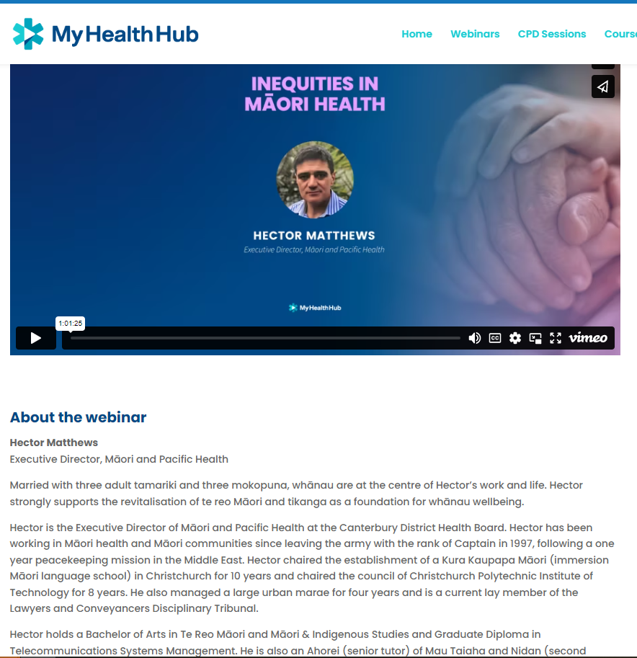

There is a repeat of the great De-escalation for practice staff session we held last year for anyone who missed out:

My Health Hub – De-escalation

Wednesday 29th March 2023 – 7pm – 8pm - Zoom Webinar
Presented by : Elle Chadwick – Mental Health Educator and Emmy Smart – Educational Psychologist

Online : use this link - De-escalation - myhealthhub.co.nz

