Mahitahi Hauora Education Update – July 2023

Professional development
For more professional development opportunities, please visit Home page - Mahitahi Hauora Primary Health Entity

Scroll down on front page and you will find a box Education for Health Professionals
Or go to HEALTH & WELLBEING PARTNERS Professional Development in second column
Or https://education.mahitahihauora.co.nz/w/upcoming/
Look out for weekly Professional Development Medinz – Thursday morning at 10am highlighting upcoming Professional Development opportunities in Northland.
Back issues of this Education update are available on the Mahitahi website

Mahitahi Hauora Education sessions
More information available via our education website - Home page - Mahitahi Hauora Primary Health Entity

Early CKD – Practical information
Te Whatu Ora Early CKD team are keen to share new resources and information for patients and General practice teams with the view to finding out how they can assist with the ultimate aim of reducing or slowing the progression of the number of patients reaching end-stage kidney disease.
Tuesday 25th July 2023 – 7.00 – 8.00pm – Online - Register via this link : https://education.mahitahihauora.co.nz/register?sgid=704a27852cda401ea6dc6d4b9df2707f

Free to Te Tai Tokerau Health Professionals
The Early CKD speakers will be:
Dr Walaa Saweirs - Consultant Nephrologist
Tracey Saweirs - Clinical Nurse Specialist
Rian Gale - Quality Coordinator - Kairuruku Kounga - Early Chronic Kidney Disease

Assisted Dying – two years on
Live Online
Tuesday 22nd August 2023 – 6.30pm – 7.30pm
Overview of Assisted Dying Act, what happened in the first year, patient journey, how to handle requests from patients, First hand Practitioner experience and perspective.
Register via this link : https://education.mahitahihauora.co.nz/register?sgid=45e3ab3d18ed463fb354cffb37370f2c
Free to Te Tai Tokerau Health Professionals

Predict DAR Training – Advanced – Troubleshooting
Live Online
Wednesday 30th August 2023 – 12.30pm – 1.30pm
Predict DAR Trouble shooting training with Chris Perri from Enigma – Designed FREE to Mahitahi Hauora Practices lead nurses or Practice Managers
Register via this link : https://education.mahitahihauora.co.nz/register?sgid=231dd73d69094423b676e8a0534da1f8

Making the most of your Health Coach & Health Improvement Practitioners
Live Online
Wednesday 20th September 2023 – 6.30pm – 7.30pm
Find our more about the Te Tumu Waiora model in general practice, hear success stories of Health Coaches and Health Improvement Practitioners and how this can be good for you and your patient
Presented by: Emma Usmar, Susan Jordan, Alyson Lloyd, Dr Sue Ward
Register via this link : https://education.mahitahihauora.co.nz/register?sgid=d8e41219fcbf4df39e901be0932054b9

IMAC Vaccinator Update
In person – register direct with IMAC
Tuesday 24th October 2023 – 1.00pm – 4.30pm in Kerikeri
Register via this link : IMAC - Vaccinator update (in-person)

IMAC Vaccinator Update
In person – register direct with IMAC
Wednesday 25th and Thursday 26th October 2023 – 9.00am to 5.00pm in Kerikeri
Register via this link : IMAC - 2 day Vaccinator Foundation (in-person)

CPR courses – week of 30th Oct to 2nd Nov
Register now – Whangarei
Tuesday 30th October to Friday 2nd November 2023
Email education@mahitahihauora.co.nz to secure your place – Include Level of CPR required and your email address
Register via this link : CPR Courses

Health Related Education sessions
Visit the Mahitahi Hauora Education Update archive on our Education for Health Professionals webpage for more listings. Education for health professionals - Mahitahi Hauora

My Health Hub – Mobile Health Palliative Care Webinar – Tender Conversations
Wednesday 26th July – 7pm – 8pm - Via Zoom
See attached poster with Registration required via this link : Mobile Health - Webinar registration

Te Tai Tokerau Primary care Diabetes Symposium – EOI
Open to all practice nurses, health improvement practitioners, community pharmacists, dietitians, paramedics and GP’s
Saturday 30th September 2023 – 8.30am – 4.00pm
Free event – limited to 120 participants. Flier attached
Register early : Diabetes Symposium

Code of Rights, Privacy, Confidentiality & Choice – Mahitahi Study session - online
16 November 2023 - 12.30pm to 1.30pm – Lunch time session
With Jessica Buddendijk from Mobile Health/ Rural Health Development
To register for this FREE course please use this link: education@mahitahihauora.co.nz

Te Whatu Ora Te Tai Tokerau Primary Care Diabetes Symposium
Expression of Interest
30th September 2023 – 8.30am to 4pm Semenoff Stadium Whangarei
Use this link to register your interest
Te Tai Tokerau Primary care Diabetes Symposium - Expression of Interest (office.com) register your interest and

Cervical Screening training for Nurses – Family Planning and Well Women provide this training in Auckland
Family Planning – Cost $1100 inc GST subsidies available 2.5 day course
14th August 2023
4th September 2023
30th October 2023
27th November 2023
Check out their website https://www.familyplanning.org.nz/courses/course?id=337

Well Women – Cost $1000 2 day course Plus online & written
14th & 15th August 2023
16th & 17th October 2023
4th & 5th December 2023
Check out their website https://www.wellwomenandfamily.co.nz/copy-of-cervical-sample-taker-s-course-1

HPV Educational video – Overview of HPV Primary Screening

An updated educational video, Overview of HPV Primary Screening, has now been completed and can be found on the NSU Health Professionals Resources Education and Training Page at https://www.nsu.govt.nz/health-professionals/national-cervical-screening-programme/hpv-primary-screening/hpv-primary

AIR Cutover Series future webinars
The cutover from the NIR and CIR to the Aotearoa Immunisation Register is getting closer and we will be running a series of webinars designed to provide information on what this means for you and how to prepare. Join the AIR Team online for the latest on the AIR. Presenting will be: Loren Shand - AIR Programme Lead Bronwyn DOliveira - AIR Product Owner Sarah Keenan - AIR Change Management Lead We look forward to showing you how we plan to help you with the new features to be implemented in AIR. By registering for the series you will receive invites to all remaining webinars and receive email reminders before each webinar.
Date & Time
- Aug 1, 2023 11:00 AM
- Aug 17, 2023 02:30 PM
- Sep 5, 2023 02:00 PM
- Sep 19, 2023 02:00 PM
Webinar Registration - Zoom

Reminder
All Mahitahi Hauora recorded education sessions are available on Mahitahi Hauora – Education for Health Professionals website

We are working on many other courses and will publish more dates and times when we get confirmation.
Keep an eye on our education site to register and find out more information. https://education.mahitahihauora.co.nz/w/upcoming/

If you have any questions regarding training or are looking for more information, please contact our Education Team on Ph 021 869 712 or education@mahitahihauora.co.nz

Training idea for the month
Cultural safety
There have been questions about what training is available to meet Foundation Standards.

Training is available in a number of ways:
- Mahitahi Hauora training sessions run by Mobile Health or Health Hub - we have run this course in June 2023 and the next one is 26th of October at 12.30pm – register at Mahitahi Education https://education.mahitahihauora.co.nz/w/
- ACC have information for their providers about understanding cultural safety on their website https://www.acc.co.nz/for-providers/provide-services/cultural-safety-and-competencies/#understanding-cultural-safety-video and a pdf guide on this site. There is a hour long YouTube webinar https://www.youtube.com/watch?v=H8mh5KHfNbs created by senior principals at Mauri Ora which could be used for training for your staff. At 37-38 minutes into this presentation there is valuable information on self-reflection for health professionals and questions to aid you to develop and review plans and self-reflections about consultations.
- Mauri ora – online course 10 hours over 52 weeks cost $99 https://members.mauriora.co.nz/course/cultural-competency-and-cultural-safety
- https://www.rnzcgp.org.nz/running-a-practice/the-foundation-standard/turoro-patients/41-responsiveness-to-diversity/ This is the link to the indicator for Cultural Responsiveness resources, the need to identify what training is needed to cover their practice population needs.
- https://www.akohiringa.co.nz/education/being-culturally-competent-is-not-enough-bulletin-4
- https://www.hqsc.govt.nz/resources/resource-library/learning-and-education-modules-on-understanding-bias-in-health-care/

Check out the Akohiringa.co.nz website for a recorded seminar – Ideas on culturally safe consultations – A discussion on communicating to improve medicine access equity. Drs Sarah Sciascia, Bronwen Chesterfield, Kyle Eggleton and Lucy O’Hagan discuss racism, prescribing bias, cultural safety and pro-equity practice.

In house training and viewing of these modules and team discussions would need to be documented fully for your Foundation assessor to be able to understand what has been covered in the trainings.
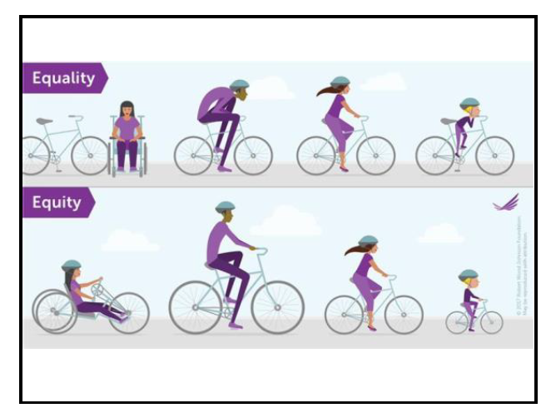

Queries or ideas
Any queries or comments on this Education update or any training or education ideas you may have; please contact Education@Mahitahihauora.co.nz or Phone Rae Jones on 021 869 712

