Mahitahi Hauora Education Update – August 2023

Professional development
For more professional development opportunities, please visit Home page - Mahitahi Hauora Primary Health Entity

Either scroll down on front page and you will find a box on Right hand side Education for Health Professionals
Or go to HEALTH & WELLBEING PARTNERS Professional Development in second column
Or https://education.mahitahihauora.co.nz/w/upcoming/
Look out for weekly Professional Development Medinz – Thursday morning at 10am highlighting upcoming Professional Development opportunities in Northland.
Back issues of this Education update are available on the Mahitahi website under Education for Health professionals along with any Education sessions that have been recorded and stored under Mahitahi Hauora Education session recordings.

Mahitahi Hauora Education sessions
More information available via our education website - Home page - Mahitahi Hauora Primary Health Entity

Assisted Dying – two years on
Live Online
Tuesday 22nd August 2023 – 6.30pm – 7.30pm
Overview of Assisted Dying Act, what happened in the first year, patient journey, how to handle requests from patients, First hand Practitioner experience and perspective. Please send any questions you have to Education@Mahitahihauora.co.nz
Register via this link : https://education.mahitahihauora.co.nz/register?sgid=45e3ab3d18ed463fb354cffb37370f2c

Predict DAR Training – Advanced session – Troubleshooting
Live Online
Wednesday 30th August 2023 – 12.30pm – 1.30pm
Predict DAR Trouble shooting training with Chris Perri from Enigma – Offered FREE to Mahitahi Hauora Practices lead nurses or Practice Managers – please send your key staff to this session so that this process goes more smoothly for you and your teams.
Register via this link : https://education.mahitahihauora.co.nz/register?sgid=231dd73d69094423b676e8a0534da1f8

Code of Rights, Privacy, Confidentiality and Choice – Mahitahi study session
Live Online
Tuesday 12 September – 6.30 – 7.30pm
Understanding the Code of Rights and responsibilities as a healthcare provider, Privacy Act, informed choice & consent.
Register via this link : https://mobilehealth.zoom.us/webinar/register/WN_CXRb4qZbSz--3_EVWwivFg#/registration

Making the most of your Health Coach & Health Improvement Practitioners
Live Online
Wednesday 20th September 2023 – 6.30pm – 7.30pm
Find out more about the Te Tumu Waiora model in general practice, hear success stories of Health Coaches and Health Improvement Practitioners and how this can be good for you and your patients.
Presented by: Emma Usmar, Susan Jordan, Alyson Lloyd, Dr Sue Ward
Register via this link : https://education.mahitahihauora.co.nz/register?sgid=d8e41219fcbf4df39e901be0932054b9

Te Tiriti o Waitangi – Mahitahi Study Session with Mobile Health
Live online
Tuesday 10th October 2023 – 6pm – 7pm
Register via this link https://mobilehealth.zoom.us/webinar/register/WN_wEmGpkMaRiaeIPLNQES_QA#/registration

These two courses are often done together so please register for both to get the links sent to you direct from Mobile Health

Inequities in Maori Health – Mahitahi Study Session with Mobile Health
Live online
Tuesday 10th October 2023 – 7pm – 8pm
Register via this link https://mobilehealth.zoom.us/webinar/register/WN_3EPc3aekSnWtRNVYOGhXYQ#/registration

ADHD New Health Pathway
Live online
Tuesday 17th October 2023 – 6.30 to 7.30pm
Presenters Ailsa Tuck Paediatrician Child Health Centre TWO Northland and Sarah Castle from TRK
Registration will be available soon on Mahitahi Education website

IMAC Vaccinator Update
In person – register direct with IMAC
Tuesday 24th October 2023 – 1.00pm – 4.30pm in Kerikeri
Register via IMAC Website

IMAC Vaccinator Foundation – 2 day course
In person – register direct with IMAC
Wednesday 25th and Thursday 26th October 2023 – 9.00am to 5.00pm in Kerikeri
Register via IMAC Website

Cultural Safety – afternoon study session
Live online
Thursday 26 October 2023 – 12.30 to 1.30pm
Register via this link https://mobilehealth.zoom.us/webinar/register/WN_mVmsD9SDTcakuqPIQwEh1A#/registration

CPR courses – week of 30th Oct to 2nd Nov
Register now for Kaitaia, Kerikeri and Whangarei
Monday 30th October - Kaitaia 6pm
Tuesday 31 October – Kerikeri 10am, 2pm & 6pm
Wednesday 1 November - Whangarei 6pm (daytime class to be arranged)
Thursday 2nd November – Whangarei 10am, 2pm & 6pm
Visit https://education.mahitahihauora.co.nz/w/ to register.
Next CPR courses will be in Late Feb or early March 2024.

Well Women & Family Trust – WONS Cervical Screening Training
Monday 13th November & Tuesday 14th November – all day sessions
Face to face at Mahitahi Hauora 28 Rust Ave Whangarei
Register via this link https://www.wellwomenandfamily.co.nz//cervical-sample-taker-s-course-2

Infection control for practice – Mahitahi Hauora study session with Mobile Health
Live online
Wednesday 22nd November 2023 – 6.30 to 7.30pm
Register via this link https://mobilehealth.zoom.us/webinar/register/WN_QnDWaL1XTYOizpGBOxVBOg#/registration

Health Related Education sessions
Dated and timed sessions that we have heard about:

Collaborative Aotearoa Conference – Catalysing Change to Deliver Equity for Whanau
29th & 30th August – Wellington
Check out the Programme here - Programme - Collaborative Aotearoa.
We are excited to share some additional detail about our upcoming conference - which will not disappoint. There will be storytelling from Jehan Casinader and Dave Letele as well as international speakers.
You will also get to meet the Te Ara Ako Study Tour delegates and hear first-hand their learnings and call to action.
Here is a short video about their mahi whilst in Canada back in May.
Te Ara Ako Study Tour clip
The Collaborative Aotearoa are offering a 40% discount to support additional registratons for practices that are experiencing barriers to attendance. Please apply for this subsidy by filling out this form Collaborative Aotearoa Conference 2023 (office.com) by Friday 18 August 2023.
The Colllaborative Aotearoa Conference will be a transformative event to learn from other exemplar practices on topics relating to improved access to care, cultural competency; comprehensive care teams, elevating whānau voice, digital assistant, and collective action in a locality setting.

Te Tai Tokerau Nursing Information Roadshow
For Nurses considering Post Graduate Study in 2024 – Come along to the Te Tai Tokerau Nursing Roadshow.
New to Study Focus All Welcome – Via Zoom – 30 Min sessions – Thursday 22nd – 31st August 2023

Upcoming Skin Cancer in the elderly – Online course
Saturday 19th August 2023 : online via Zoom Webinar - 8.30am – 12.30pm
Melanoma Network of New Zealand (MelNet) is running a four-hour online course focused on the identification and management of skin cancer in the elderly. I would be grateful for your assistance in distributing material on this event to primary health and residential care providers within the Te Whatu Ora network.
Cost: $80 (including GST).
Skin Cancer in the Elderly - Formstack

International Expert Series on Asthma & COPD for NZ Health Professionals
Thursday August 31st 2023, 6pm, Tonic Restaurant, Kamo.
Your asthma and COPD questions answered by Associate Professor Christopher Worsnop, a live streamed event.
Register by contacting Krishna Shah on 021 938 676 or Krishna.x.shah@gsk.com
RSVP required by 24th August 2023.

Goodfellow Unit – Webinars
Click this link to view webinar information : Goodfellow Webinars - August & September
Tuesday 22 August : Sepsis – how not to miss it
Tuesday 29 August : What’s New: Surviving the digital deluge – efficient inbox management
Saturday 2 September : Primary Care Update 2023
Tuesday 12 September : Managing complex patients with multiple conditions
Tuesday 19 September : Adult transgender patient care

Goodfellow Unit – Primary Care update
Saturday 2nd September 2023 – 8.30am to 3.20pm
Full webinar day for GP’s, primary care nurses, nurse practitioners, nurse prescribers, pharmacists or anyone who wants to keep up to date across the whole field of primary care.
Follow this link for more info and to register : Primary Care Update 2023 | Goodfellow Unit

Health Promotion Forum of NZ Certificate of Achievement in Introducing Health Promotion
See use this link to access information about this online course starting September 2023 : healthpromotionforumofnewzealand.cmail19.com/t/i-e-asdkht-juhiirahr-p/

APGANZ 2023

- APGANZ are holding a one-day session on September 16 2023 9.30am – 7.00pm at Grafton Campus, University of Auckland covering Excellence and innovation in a changing landscape : Professionalism in abortion care.
- See attached web page, visit www.apganz.org.nz or email admin@apganz.org.nz for more information.

NZ Respiratory conference 2023
16th & 17th November 2023

As the Early Bird ticket pricing closes on the 31st of August, this is a reminder that it's still not too late to register and take advantage of the special offer. www.NZRC2023.co.nz

My Health Hub webinar series
Tuesday 12 September – 1pm to 2pm
Cyber Security: a “101” session for Health Professionals
Nick Baty has over 18 years security experience, for many health care providers (particularly those in the small to medium sized or rural domains) managing cyber security can appear a daunting task.
Register for this free session at https://tinyurl.com/MHHCYBER

Long Acting Reversible Contraception (LARC) Training
Free LARC training is available to Te Whatu Ora and Primary Care practitioners (RN, GP & Midwives) from Kensington Health. This is a teaching clinic for a limited time only and is free for consumers.
The LARC training meets the LARC 2022 Standards -Long-acting Reversible Contraception Health practitioner training principles and standards 2022
Health Practitioner Information Application forms for Health Practitioners wanting to train in LARC procedures can be found here:
LARC-training-process-and-application-forms.pdf (kensingtonhealth.nz) or email larc@kensington.health.nz
For more information go to this website: FREE Contraception Clinic - Kensington Health

Whakamāoritia tō ao – Indigenise Your World Through Mahi a Atua
- Te Aka Whai Ora have partnered with Te Kurahuna to deliver the Mahi a Atua professional and personal development programme over the next two years.
- This is available to all clinical and non-clinical hauora Māori kaimahi from across the motū, Mahi a Atua is provided by Te Kurahuna, specialists in delivering training and professional and personal development for hauora Māori kaimahi from a mātauranga Māori and Te Ao Māori perspective.
- For more information and to register, visit Become a Mataora | Te Kurahuna (mahiaatua.com)

We are working on other courses and will publish more dates and times when we get confirmation.
Keep an eye on our education site to register and find out more information. https://education.mahitahihauora.co.nz/w/upcoming/

Hopefully your team are all enrolled in Medinz, as we advertise clinically relevant courses by email each week at 10am Thursday.

If you have any questions regarding training or are looking for more information, please contact our Education Team on Ph 021 869 712 or education@mahitahihauora.co.nz

Training idea for the month
Help for General Practice staff
https://podcasts.apple.com/au/podcast/permission-to-thrive-dr-rachel-morris/id1411545703?i=1000528121885
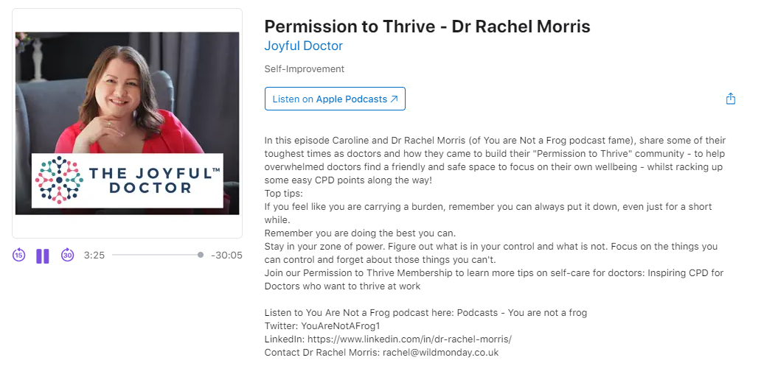

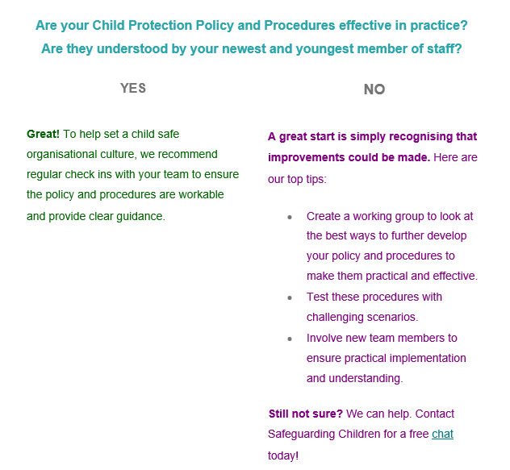

Queries or ideas
Any queries or comments on this Education update or any training or education ideas you may have; please contact Education@Mahitahihauora.co.nz or Phone Rae Jones on 021 869 712

