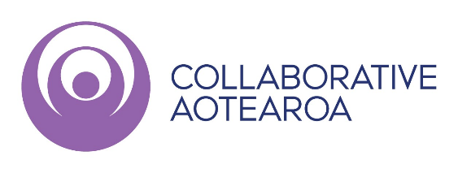
Collaborative Aotearoa Conference 2023
Me Pēha tātau e āwhina ai?
How can we help?

Conference Presentation Index

Day One
0945 - Sarah Precious and Megan Lynch - Building Community Health and Wellbeing together.
1115 - Panel: Achieving Equity through Sustained Collaboration
1200 - Monique Davidson How the future for local Government intersects with Health
1345 - Amarjit Maxwell & Irihāpeti Mahuika -Collective Action with Communities
1345 - Elevating Whānau voice - Panel
1345 - Justin Butcher & Jo Scott Jones - Comprehensive care teams in Action at Pinnacle
1415 - Aimee Wallace - Practice Management System Digital Assistants at Procare
1515 - Riiti Conway & Emma May Loretz - Wānanga Tokeke with WellSouth
1515- Ruth Robson & Neil Whittaker - Equity and Health Care Home in a rural environment
1515 - Dr Helen Lockett - Whakairo - Mental health & Substance use issues of NZ

Day Two
0845 - Sylvia Cheuy - Amplifying Collective Action with Communities
1015- Te Ara Ako Delegates - Study Tour-Sharing our knowledge for the future
1330 - Helmut Karewa Modlik - He Waka Eke Noa - We're all in this together
1400 - Jude MacDonald - Piki Te Ora Horoa - True partnership in honouring Te Tiriti o Waitangi
1400 - Lindsey Webber & Kiri Peita - True partnership in honouring Te Tiriti o Waitangi
1430 - Dr Andrew Miller - Working smarter, not harder to improve healthcare access for whānau
1430 - Dr Janine Bycroft - Working smarter not harder to improve healthcare access for whānau
1430 - Michael Rongo & Maria Uluilelata - Transforming Hauora in the Porirua locality
1430 - Lovey Ratima-Rapson - Of Manaaki and Mana
1530 - Prudence Walker - Promoting and protecting the rights of tāngata whaikaha and disabled NZ
1600 - Tania Carr and Panel - Rangatahi are our future - Looking back to look forward

