VENEPUNCTURE

TRAINING FOR
EXTERNAL
HEALTH
PROVIDERS
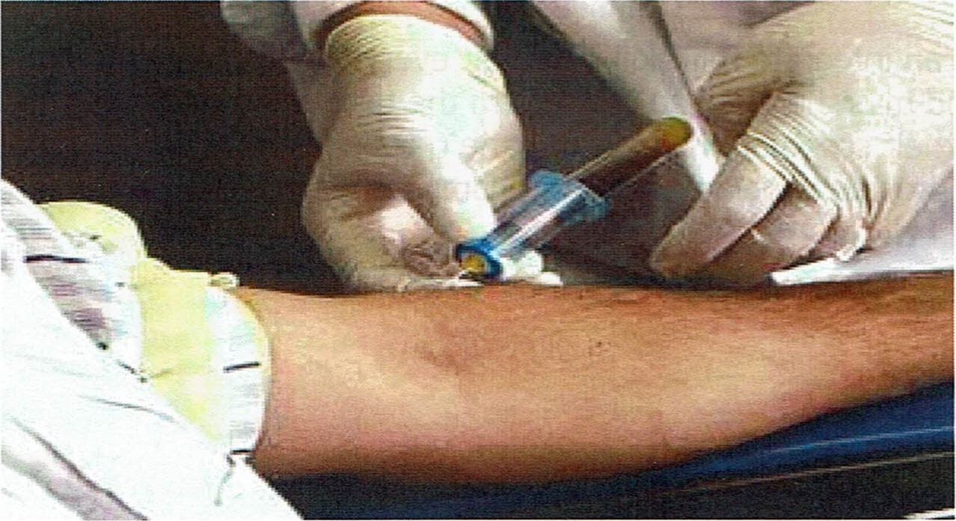

INTRODUCTION
Nurses within a variety of healthcare environments are increasingly taking blood samples / performing Venepuncture.
Venepuncture is the term applied to the procedure of entering a vein with a needle in order to obtain a venous blood sample for a range of laboratory tests

AIM
This training will outline the procedure for taking blood samples having first considered the various issues that are associated with the procedure. These issues include legal and professional implications, patient assessment and preparation, and the recognition and management of complications.

LEARNING OUTCOMES
At the end of you training the participant will be able to:
- Discuss Safety and infection control procedures relating to Venepuncture.
- Locate and identify the veins commonly used in venous collection
- Explain the principle of informed consent in the context of Venepuncture
- Outline the procedure for taking a blood sample
- Discuss the potential complications associated with Venepuncture
- Describe measures management strategies to prevent complications

PREREQUISTIES
Only staff that can integrate this skill into their everyday practise should undertake this training. And must be certified to perform the task of Venepuncture as a core practice within their scope of practice. It is the responsibility of the attendee's organisation to provide ongoing education, competency and any professional liability.

NEEDLE STICK INJURY
As a collector, you will be working with needles all day. It is important that you use the correct technique when collecting blood so as to minimize your chance of injuring yourself.
Currently, the recommended way to treat a Needle stick injury is to encourage the wound to bleed, wash in soap and water, dry and cover.
Please follow your organisations needle stick protocol.
THE SHARPS CONTAINER

NEVER RE-CAP
When disposing of your needle, always handle a sharps container carefully; never handle in a rough manner.
Always observe the Fill Line on the sharps container, generally, never fill a sharps container more than ³/4 full.
Statistics have shown that most Needle stick injuries occur when re-sheathing a needle or due to over filling of a sharps container.
Ensure the sharps container is mounted securely

THE REQUEST FORM
- The request form is a legal document given to the Patient by the referring Doctor. The request form is also a very important communication tool; it allows the Doctor to communicate his/her wishes to the collector and to convey information to the Laboratory.
  - Patient Details
    - You must confirm that you have the correct patient before commencing the procedure.
    - If a patient is not eligible for Health PAC funding of laboratory test then they must pay. Indicate clearly on the form how the patient has been charged.
      - Before collection
  - Check spelling is correct:
  - Patients full name
  - Date of birth
  - NHI
  - Current Address
  - Phone numbers
- Indicate on the form whether the patient has been fastinq or not — if applicable Indicate on the time the last dose was give — if applicable
- Following collection
- Full name of collector
- Time and date of collection Tubes Taken
- Referring Doctor Details
  - It is important for legalities and billing that the referring Doctor's details are on the request form.
- Always check to see that request form has been signed by the Doctor.

SPECIMEN LABELLING
- It is a requirement of IANZ that for a specimen to be considered adequately labelled it must have a minimum of 2 key identifiers of the patient. These identifiers might be the patients full name, date of birth or NHI number.
- All tubes, containers and slides are to be labelled immediately after the specimen has been collected and before the patient has left the collection room, you must never label any container with patient details before collecting the sample.
- Before the patient leaves the collection area you must ensure the patient has checked their details on all collected specimens.
- If patients require collection containers to take away, for example faeces or urine containers do not pre label the container

PATIENT FEARS
Most people have a fear of needles or blood taking. Always acknowledge your patients fear, it is very real to them. See what you, as a professional, can do to make them feel more comfortable. Some patients like to discuss the procedure and view the equipment that will be used, others may not want to watch or discuss the procedure.
You may want to lay the patient down to prevent them from fainting. When discussing your patient's fears never ridicule or embarrass the patient. The fear is very real to your patient, no matter how unreasonable it may seem to you. Often, it is the perceived loss of control that causes a patient's anxiety. It is good practice with a nervous patient to tell them before starting that if at any time they need to, they can ask you to stop and you will.
Never tell your patient "this won't hurt", the fact is, it does.
At any time your patient says NO, you must respect this. If you are part way through a procedure and your patient tells you to stop, you must. If you continue with the procedure after the patient has said NO, then you are committing assault.

INFORMED CONSENT
You must, at all times, ensure that the patient understands what you are about to do to them and agrees to you doing this. This is informed Consent. If the patient does not understand what it is that you are about to do, and you continue, this is also assault.

PATIENT INSTRUCTIONS
There are many tests that require the patient to prepare prior to testing, or to collect the specimen in a particular way. Northland Pathology will supply patient instruction sheets to help explain these procedures to the patient. These instruction sheets are available to print from NPL website
There will be times when you will have a patient faint or fit whilst you are performing Venepuncture. If this happens, release the tourniquet, remove the needle, ensure the area is safe and let them slide to the floor & raise their legs.
Do not attempt to restrain the patient or break their fall, you will only injure yourself. If the patient is fitting, do not attempt to put anything in their mouth. Once your patient has recovered, ask them to sit for a short while and assess how they are feeling. It is your duty of care to ensure they have fully recovered before allowing them to leave the collection area.
If the patient has not recovered in a reasonable time (two minutes) call for assistance.
To prevent fainting during a blood test:
First check if the patient has ever fainted during a blood test, if so lie the patient down. A faint is usually short lasting and will cause no permanent damage.
First check if the patient has ever fainted during a blood test, if so lie the patient down. A faint is usually short lasting and will cause no permanent damage.

HAEMATOMAS
Haematomas (bruises) can occur due to the needle passing directly through the vein, if this happens, you will notice a bluish swelling appear. Haematomas can also appear if the tourniquet is not removed before the needle is withdrawn, the Vacutainer tube is not removed from the needle before the needle is withdrawn from the skin or the puncture site has not had sufficient firm pressure applied post Venepuncture.
Some patients will bruise regardless of your technique; often these patients are on medications or have medical conditions that cause them to bruise easily.
Always advise your patient not to carry or lift anything post-collection for at least one hour.
To prevent bruising and bleeding after a blood test:
Avoid excessive movement such as: digging, jogging, and carrying heavy objects/children etc. as the arm involved may become bruised.
Pressure is required to minimize bruising and prevent bleeding (clot forms)
Remove dressing in approximately 15 minutes otherwise tape may cause irritation.
If you experience pain either during or after a blood test:
The cause of the pain may be one of two things:
either the vein has been punctured on both sides causing blood to leak into the surrounding tissues or a nerve has been injured, Ice may be applied to the site.

THE TOURNIQUET
In order to select a vein, we must palpate (feel) for a suitable vein. To aid in the selection of a vein, we apply a tourniquet to make the veins more pronounced. When applying a tourniquet, it should be 5-15cm above your selected site.
Always place two fingers under the tourniquet when fastening it on your patients arm so as to avoid bruising or skin tears.
If using a Tourniquet that fastens with a clasp, have the clasp opening facing away from the patient. If the clasp is released quickly under pressure, it may flick up and hit the patient in the eye / face and cause injury.
The tourniquet only needs to restrict the flow of blood in the vein don't overly tighten, as this will cause pain or discomfort to the patient.
The Tourniquet should not be kept tightened on the patient for longer than 1 minute
Wash your tourniquet regularly. Simply wash in warm soapy water and hang to dry overnight.
If your tourniquet is heavily soiled with blood, dispose of it.

SELECTING A SITE
When choosing a vein, you need to consider whether it is in an easily accessible area, can the area be supported (on desk or work area), can a tourniquet be applied?
The preferred site for performing Venepuncture is within the Cubital Fossa (the inner aspect of the elbow). If this is not available, you can go to the back of the hand or the foot although these areas are not very comfortable for the patient and the flow of blood tends to be slower. Most of your Venepunctures will be in the Cubital Fossa. This area is easy to access; generally the veins in this area have reasonable volume and are generally quite stable.

SITES NOT SUITABLE FOR VENEPUNCTURE
When selecting a site to perform Venepuncture, there are some areas which should be avoided, they are:
Bruising
A bruised area may affect the results of some tests (due to the sample picking up dead blood from the bruise) and may cause discomfort to the patient.

Lesions
May cause discomfort to the patient.
Burn Area
An increased risk of infection.
Mastectomy
Patients, who have had a mastectomy or removal of Lymph Glands from the axilla, should only have blood taken from the opposite side to the surgery. Applying a tourniquet to the side of the surgery may cause unnecessary swelling or Lymph oedema.

Fistulas I Cannulas
Patient receiving dialysis will have a fistula, usually in the forearm. Under no circumstances apply a tourniquet or collect blood from this arm.
Intravenous Therapy
It is best to avoid collecting blood from the same arm that contains an intravenous infusion; the sample will be contaminated with the infusion content. If it is unavoidable, ask the treating Nurse or Doctor to shut off the IV, wait ten minutes and collect from below the IV site. Never shut off or re-start patients IV always request the treating Doctor or Nurse to do this.
Inside wrist
VEINS OF THE CUBITAL FOSS 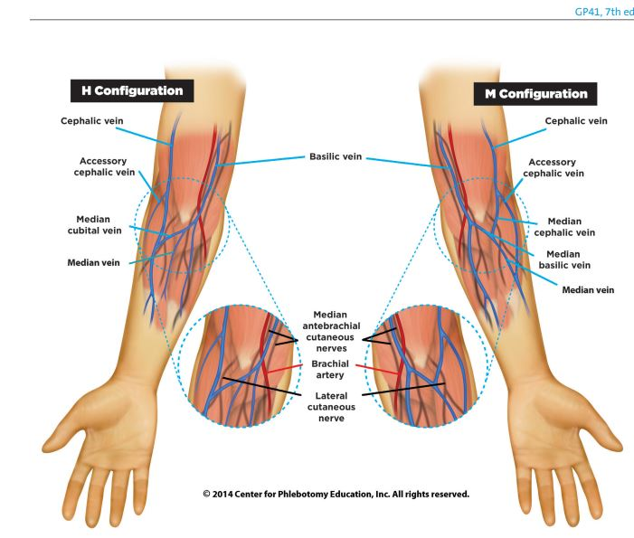Common arrangement of veins in the cubital fossa

PALPATING
Palpating is how you locate a suitable vein for Venepuncture. When you palpate, use the fingers of your less dominant hand to feel for a vein. Use only the fingers and not the thumb, the thumb has a pulse of its own.
First push gently down on the selected area to determine if you have located a vein, artery or tendon. (If it is a vein it will not have a pulse and will spring back from being depressed)
Once you have decided that it is a vein, you need to determine that it has suitable volume in it for your Venepuncture; you also need to determine that the vein is stable and will not roll away from your needle. You can do this by rolling your finger over the vein, if the vein rolls away from your finger it is unstable and needs to be anchored.
It is good practice to get into the habit of looking away whilst palpating. Your eyes may be able to tell you where an obvious vein is located, but only the feel of your finger will be able to tell you the volume and stability of the vein.
You must be confident that you have palpated a vein that has both volume and stability.
Never go in to a patients arm without locating the vein — "Blind"
Things to remember when selecting a vein:
Accessibility — can you stand in a direct line with the vein?
Volume of blood — can the vein give the amount of blood required for the tests?
Stability — is the vein stable? Will you have to anchor it?
Artery — if the vein is pulsating it is probably an artery — STAY AWAY Tendon — a tendon feels like a bony cord — STAY AWAY
Things which may affect the vein
Temperature — If your patient is cold it will generally be harder for you to find a vein. Ensure your waiting area is adequately heated. Gentle rubbing of the selected venepuncture area can cause friction heat and will often bring up a vein, applying warmth to the area often will bring up the vein.
Dehydration — Often your patients will be fasting and slightly dehydrated. If the patient is not fasting, it is acceptable to ask them to drink as much water as they can tolerate over the next few hours and return to the clinic.
Many patients have an inadequate fluid intake. If this is the case with your regular patient, ask them to increase their fluid intake before coming for their venepuncture. Always advise a patient who has to fast, to drink as much as they can before commencing to fast.
Overuse — If your patient has regular blood tests or is an intravenous drug user, often the same vein will be regularly selected. This vein will scar and become less reliable for taking blood. Try to alternate the sites where you perform venepuncture.

PERFORMING THE VENEPUNCTURE
Equipment required to perform Venepuncture
Tourniquet
Alcohol wipe
Gauze swab
Vacutainer holder
Needle
Vacutainer tubes Plaster
Venepuncture Procedure
Introduce yourself to the patient. Check the patient's identification.
Position the patient and yourself so you are both comfortable.
Wash or sanitise your hands
Prepare the equipment to be used.
Wash your hands
Apply the tourniquet and palpate for a suitable vein.
Clean the selected site with the alcohol swab.
    - Wipe the area in a concentric circle, inside to out.
    - Don't soak the area in alcohol as this will cause the puncture to sting
    - Allow site to air dry
Put on gloves.
You should always wear gloves when handling the patient or equipment.
Gloves provide a barrier between you and potential infection.
Gloves also protect you in the event of Needle stick injury. The needle will pass through the membrane of the glove before entering your finger, wiping off much of the blood / body fluid contained on the needle.
Hold the Vacutainer
With your dominant hand and anchor the vein with your other hand.
The Vacutainer Holder should be held with the Thumb on top and the index and middle fingers underneath, supporting the barrel. The barrel should be held firmly and securely.
Push the needle through the skin, at an angle of 15-30 ⁰ .

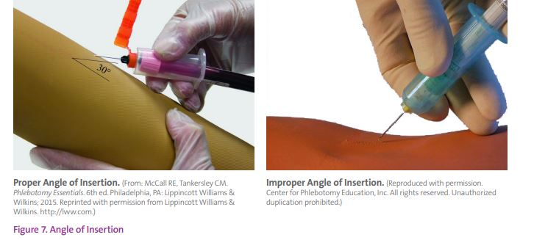

Always maintain eye contact with the needle.
The needle should always be bevel up (angle side up) and should progress into the arm at a confident constant speed.
A slow needle will cause pain to the patient.
Insert the Vacutainer tube into the Vacutainer barrel.
Maintain a good firm grip on the Vacutainer barrel. Do not move the needle.
Have the window on the tube facing you, this will allow you to see the flow of blood into the tube.
Release the tourniquet once the blood has started flowing.
Remove the final tube and remove the tourniquet.
Remove the needle.
  - The needle should exit at the same angle as it went in.
  - Avoid lifting the needle as it leaves the skin as this will hurt the patient and may cause a drop of blood to flick (possibly into your eye or mouth)
Discard your needle into the sharps container immediately.
Check if the puncture site has stopped bleeding
Usually 3 minutes, longer if on anticoagulant therapies
Apply a plaster/tape.
Advise the patient not to lift anything heavy for the next hour & remove plaster after 15 mins

BLOOD COLLECTION TUBES
Collection tubes used for blood samples are colour coded. The colour of the stopper indicates the additive in the tube.
When multiple tubes are to be collected the following order of draw should be observed.
Blood Cultures Citrate Tubes
Gel SST
Plain / Clot
Lithium Heparin Tube
EDTA
Fluoride Oxalate
EDTA Navy Tube
When collecting blood in an additive tube it is important to obtain the correct volume of blood (Due to presence of anti-coagulant in the tube. The blood to anti-coagulant ratio must be precise)
Blood collected in an additive tube must be thoroughly mixed to prevent clotting. Mix by gently inverting the tube 8 to 10 times.
If the sample is not thoroughly mixed a clot may form and this will make the sample unsuitable for testing
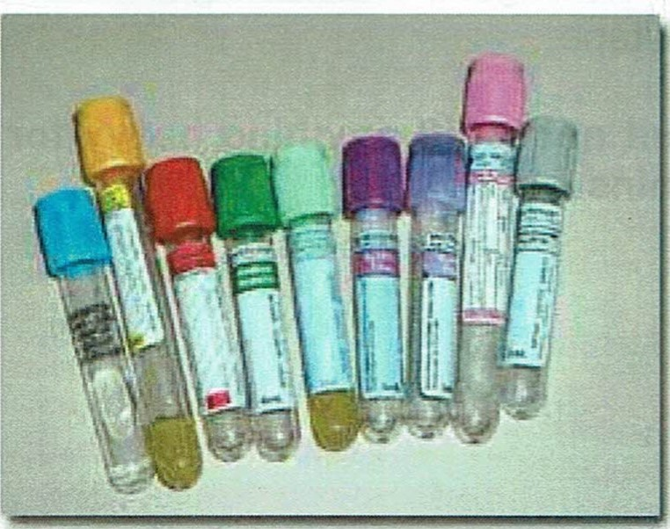

Mix Tubes by Inverting the

Recommended Number of Times
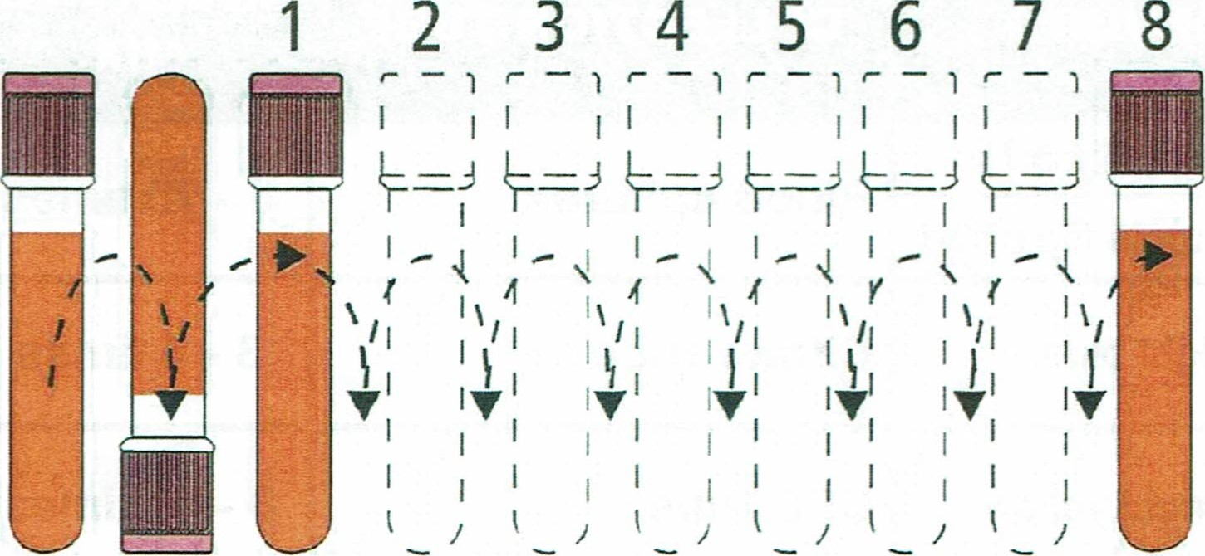
Processing of Tubes

why

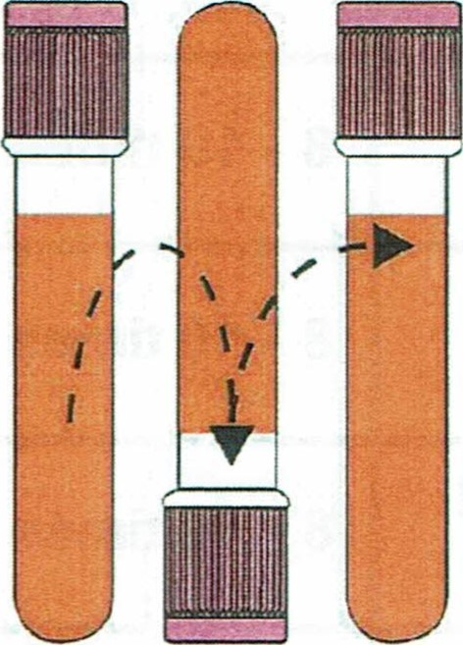
- Most tubes contain an additive or clot activator that needs to be mixed with the blood sample.
- Tubes with anticoagulants such as EDTA, heparin need to be mixed to ensure specimen does not clot.
How
- Holding tube upright, gently invert 180 degree and back.
- Repeat movement as prescribed for each tube per the illustration.
When
- Immediately after drawing.

Consequences if not mixed
- Tubes with anticoagulants e.g. EDTA, heparin will clot.
- SST tubes may not clot completely.
- Specimen will often need to be redrawn.

Troubleshooting Hints for Blood Collection
- No Blood Seen or Too little Blood Flow into The Tube
Causes Solutions
- Needle may not be placed at the center of the • Remove and reposition the tube correctly stopper causing blockage
- Needle bevel may be flushed against the wall º Rotate the needle 1/4 turn clockwise* of the vein causing blockage
- Tourniquet applied too tightly or too long • Release pressure slowly stopping blood flow
- Tube may have been previously punctured or • Replace tube tube may have previously been opened
- The needle has transfixed the vein (going • Pull back slightly on the needle holder* through the back wall of vein)
- The needle is not completely in the vein or has • Advance the needle fomard until you not reached the vein feel the "give" as the needle penetrates the vein*
- The vein has collapsed • Remove tubes. Allow vein to recover. Re-apply tourniquet. Re-insert same tubes.
- The tubes may be removed from the holder during the repositioning process, Re-insert the same tube in the holder when the needle is repositioned.

Under filling of Tubes
Causes | Solutions
- Premature removal of tube  - "Dead Space" in tubing of winged collection set | - Draw "Discard Tube" first to ensure accurate test results.  - Draw "Discard Tube" first to ensure accurate test results. Partially important with small draw (eg. 2.7ml & 1.8ml sodium citrate tubes)

3. Blood Stops flowing | Halfway | during | Blood Collection
Causes |  | Solutions
- Vein may have collapsed  - Needle may have been repositioned outside the vein during venipuncture |  | Remove the tube from Holder for a few seconds to allow the vein to fill again. Replace tube to continue collection  Repeat venipuncture at different site when hematoma occurs

4. Occurrence of Hematoma
Causes | Solutions
• Needle not completely in the vein Needle transfixed the vein  Excessive probing resulting in enlargement at the site of entry  Tourniquet placed too near the venipuncture site | Release tourniquet and remove the needle. Apply firm pressure over swollen area (or elevate affected arm). Reassure patient that the bruise will resolve. Repeat venipuncture at a different site.

5. Volume Draw Too Large
 |  | Some patients develop an abnormal accumulation of fluid in the intercellular spaces of the body. | Blood collection should be avoided from these sites because veins in these areas are difficult to palpate/stick, and specimen may become contaminated with fluid.
Obesity |  | Obese patients generally have veins that are difficult to visualize palpate. | Take extra time to locate suitable veins, e.g. massage arm, with arm hanging down, use of warm towel, etc. Take care notT probe excessively.
Intravenous  Therapy  (Damaged, Occluded Veins) |  | Patients on IV therapy for extended periods often have veins that are palpable & visible but partially occluded or sclerosed, | Avoid using the arm with the IV line.  Instead, use the other arm / site. Where necessary, the IV line can be disconnected & with the first draw discarded, sample can then be collected.
Hemo concentration |  | A sign of increased concentration of larger molecules & formed elements in the blood. Several factors can cause this complicaticn. | Avoid the followings :  - Prolonged tourniquet application  - Excessive massaging / squeezing / probing a site  - Sclerosed / Occluded veins
Hemolysis |  | Hemolysis can be caused by improper phlebotomy techniques & may also be the result of physiological abnormalities. | Avoid the followings  - Using a smaller needle, e.g. 25G and above  - Where a needle and syringe collection technique is used, do not draw or expel syringe plunger too fast. Never transfer specimen from syringe to tube via the needle  - Shaking / mixing tubes vigorously  - Failure to allow alcohol to dry

Complications Associated With Blood Collection
 | Causes | Management
Fainting  (Syncope) | Many patients become dizzy and might faint at the thought sight of blood. | Consequently, the phlebotomist should be aware of the patient's condition throughout the collection procedure. This can be done by asking ambulatory patients if they feel faint or if they have ever previously fainted during blood collections. If so, they should be moved from a seated to a lying down position. If patients faints during or after the procedure, the phlebotomist should try to terminate the venipuncture procedure immediately and make sure that the patient does not fall or become injured . Patients who faint should recover fully before being allowed to leave and should be instructed not to drive for at least 30 minutes.
Hematomas | • This complication can occur when the needle has gone completely through the vein, the bevel opening is partially in the vein, or not enough pressure is applied to the site after puncture. • Susceptibility to hematcma may be increased in patients with bleeding disorders and those receiving certain drugs (aspirin, warfarin, cortisone). Strenuous use of the arm following venipuncture may also induce hematorna. | If a hematoma begins to form, the tourniquet and the needle should be removed immediately, and firm pressure should be applied to the area for approximately 2 minutes. If bleeding continues, a nurse/doctor should be notified.
Thrombosis | Thrombi are solid masses (clots) that reside in blood vessels. Veins with thrombi are rigid / bumpy and lack elasticity. | Avoid collecting blood from thrombosed veins.

